Statistiques des importations des mollusques en Espagne et au Japon
Extrait du Document Statistiques mensuelles du GlobFish

Spain | Imports | Octopus | Frozen

MONTHLY SERIES

9

8

7

6

5

4

3

Volume

Unit Value
5000
4500
4000
3500
3000
2500
2000
1500
1000
500
0

ANNUAL COMPARISON

9

8

7

6

5

4

3
6000

5000

4000

3000

2000

1000

0

Jan
Feb
Mar
Apr
May
Jun
Jul
Aug
Sep
Oct
Nov
Dec

2012 Volume
2012 Unit Value
2013 Volume
2013 Unit Value
2014 Volume
2014 Unit Value

YTD RANGE:

TOP PARTNERS, YEAR-TO-DATE COMPARISON

Jan - Jun
14000

12000

10000

8000

6000

4000

2000

0
10
9
8
7
6
5
4
3
2
1
0

2012 YTD Volume
2012 YTD Unit Value

2013 YTD Volume
2013 YTD Unit Value

4

2014 YTD Volume
2014 YTD Unit Value
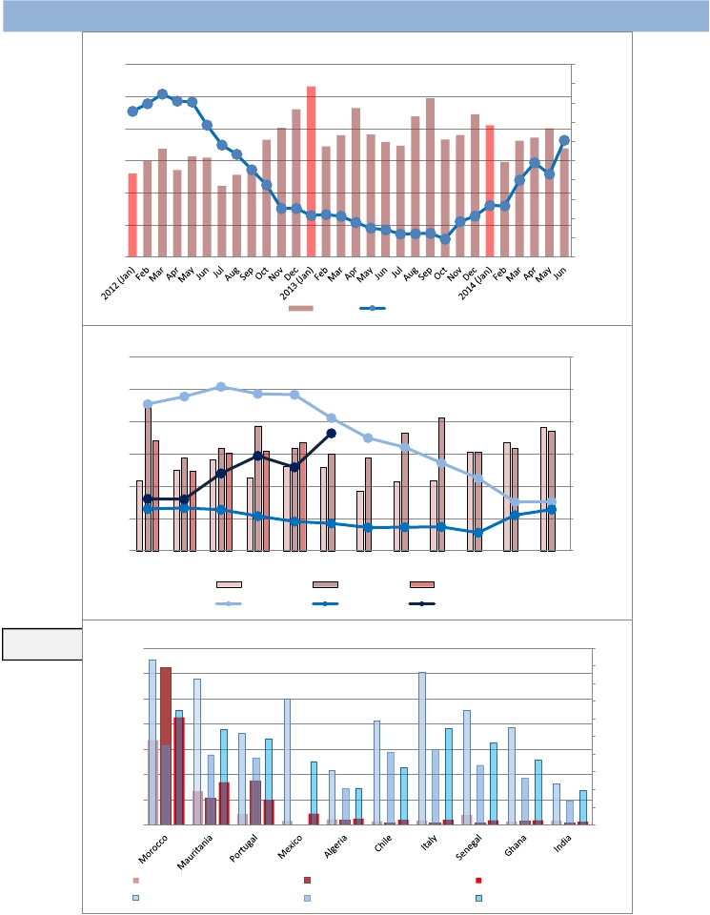

Metric Tonnes
EUR per kg
Metric tonnes
EUR per KG
Metric tonnes
EUR per KG

Japan | Imports | Octopus | Frozen

MONTHLY SERIES

12

11

10

9
9000
8000
7000
6000

5000
8
4000

7

6

5

4

Volume

Unit Value
3000
2000
1000
0

ANNUAL COMPARISON

12

11

10

9

8

7

6

5

4
12000

10000

8000

6000

4000

2000

0

Jan
Feb
Mar
Apr
May
Jun
Jul
Aug
Sep
Oct
Nov
Dec

2012 Volume
2012 Unit Value
2013 Volume
2013 Unit Value
2014 Volume
2014 Unit Value

YTD RANGE:

TOP PARTNERS, YEAR-TO-DATE COMPARISON

Jan - Jun
14000

12000

10000

8000

6000

4000

2000

0
14

12

10

8

6

4

2

0

Morocco
Mauritania
China
Vietnam
Thailand
Indonesia
India

2012 YTD Volume
2012 YTD Unit Value

2013 YTD Volume
2013 YTD Unit Value

5

2014 YTD Volume
2014 YTD Unit Value
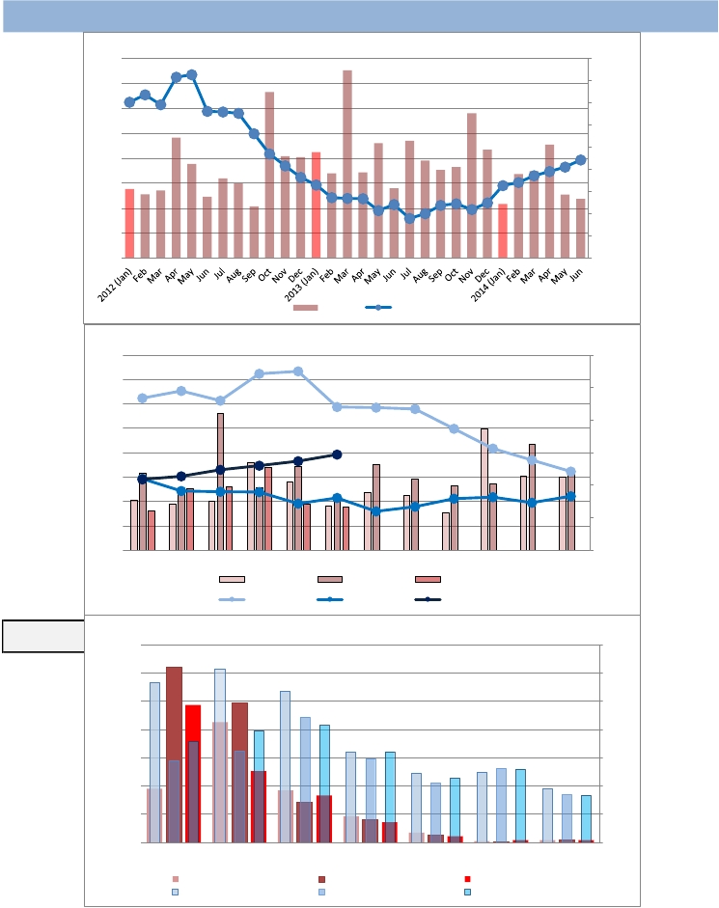

Metric Tonnes
USD per kg
Metric tonnes
USD per KG
Metric tonnes
USD per KG

Spain | Imports | Cuttlefish | Frozen

MONTHLY SERIES

5
4.5
4
3.5
3
2.5
2
1.5
1
0.5
0

Volume

Unit Value
4500
4000
3500
3000
2500
2000
1500
1000
500
0

ANNUAL COMPARISON

5
4.5
4
3.5
3
2.5
2
1.5
1
0.5
0
6000

5000

4000

3000

2000

1000

0

Jan
Feb
Mar
Apr
May
Jun
Jul
Aug
Sep
Oct
Nov
Dec

2012 Volume
2012 Unit Value
2013 Volume
2013 Unit Value
2014 Volume
2014 Unit Value

YTD RANGE:

TOP PARTNERS, YEAR-TO-DATE COMPARISON

Jan - Jun
12000

10000

8000

6000

4000

2000

0
6

5

4

3

2

1

0

Morocco
Mauritania
India
Ghana
Senegal
Tunisia
China

2012 YTD Volume
2012 YTD Unit Value
2013 YTD Volume
2013 YTD Unit Value

8
2014 YTD Volume
2014 YTD Unit Value
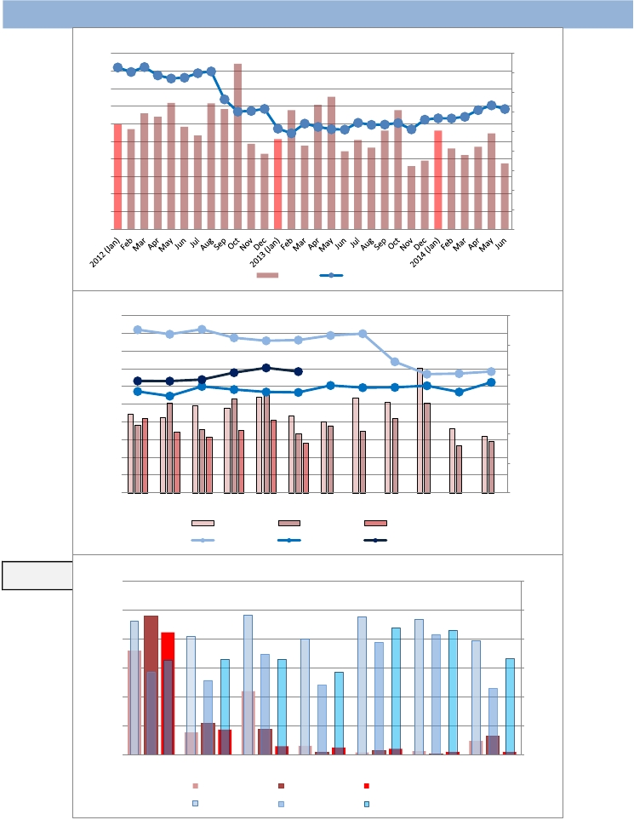

EUR per KG
EUR per KG
Metric Tonnes
EUR per kg
Metric tonnes
Metric tonnes

Spain | Imports | European squid | Frozen

MONTHLY SERIES

8

7.5

7

6.5

6

5.5

5

4.5

4

Volume

Unit Value
1600

1400

1200

1000

800

600

400

200

0

ANNUAL COMPARISON

8

7.5

7

6.5
1800
1600
1400
1200

1000
6
800

5.5

5

4.5

4
600
400
200
0

Jan
Feb
Mar
Apr
May
Jun
Jul
Aug
Sep
Oct
Nov
Dec

2012 Volume
2012 Unit Value
2013 Volume
2013 Unit Value
2014 Volume
2014 Unit Value

YTD RANGE:

TOP PARTNERS, YEAR-TO-DATE COMPARISON

Jan - Jun
4000

3500

3000

2500
9
8
7
6

5
2000
4

1500

1000

500

0
3
2
1
0

Morocco
Mauritania
2012 YTD Volume
2012 YTD Unit Value
Portugal
2013 YTD Volume
2013 YTD Unit Value
United Kingdom
2014 YTD Volume
2014 YTD Unit Value
France

9
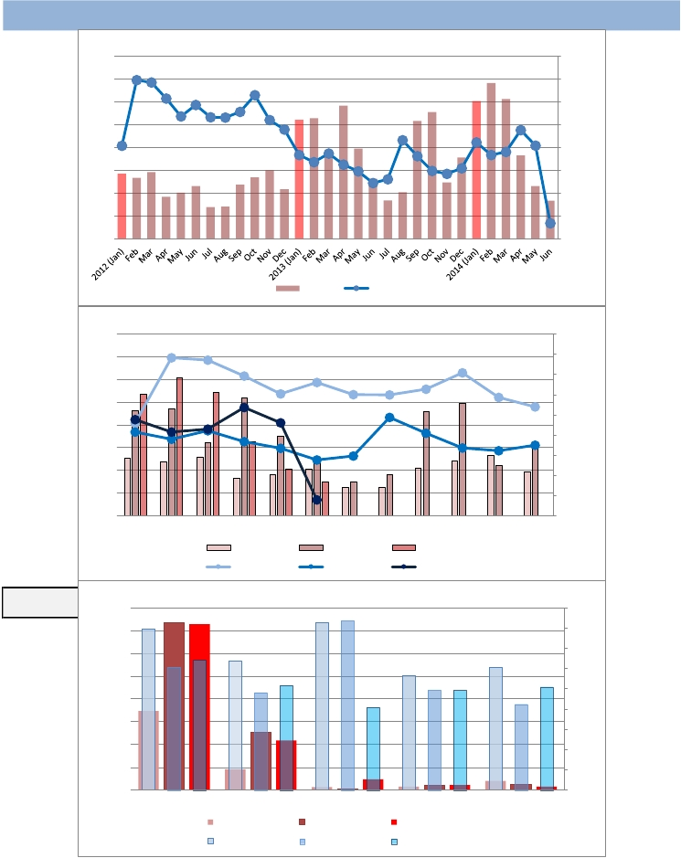

EUR per KG
Metric Tonnes
EUR per kg
Metric tonnes
Metric tonnes
EUR per KG

